Safety Alignment Effectiveness in Large Language Models
Rock Lambros
January 2026

Introduction
Large language models (LLMs) risk producing harmful content including hate speech, threats, and misinformation. Safety alignment techniques—RLHF, DPO, and SFT—aim to reduce toxic outputs while preserving utility. Despite widespread adoption, empirical evidence quantifying alignment effectiveness across model families remains limited.
This study asks: Does safety alignment significantly reduce toxic outputs, and does effectiveness differ across model families? We compare base versus aligned models from three families (Qwen 3, Llama 3.1, Mistral) using 25,000 prompts from toxicity benchmarks, quantifying absolute risk reduction via paired statistical tests.

Data and Methods
We sampled 25,000 prompts: 12,500 from RealToxicityPrompts (Gehman et al., 2020) stratified by toxicity tertiles, and 12,500 from ToxiGen (Hartvigsen et al., 2022) adversarial examples targeting 13 demographic groups.
Family | Base Model | Aligned Model | Parameters
Qwen 3 | Qwen/Qwen3-8B-Base | Qwen/Qwen3-8B | 8B
Llama 3.1 | meta-llama/Llama-3.1-8B | meta-llama/Llama-3.1-8B-Instruct | 8B
Mistral | mistralai/Mistral-7B-v0.3 | mistralai/Mistral-7B-Instruct-v0.3 | 7B
Inference used deterministic decoding (temperature = 0.0, max 128 tokens). We scored 150,000 completions using Detoxify (Hanu & Unitary, 2020) with binary threshold 0.5. For robustness, 5,000 pairs per family were validated with OpenAI Moderation API.

Statistical Methods
McNemar’s Test (Primary): For paired binary outcomes, we construct a $2×2$ contingency table where cells $b$ (base toxic, aligned non-toxic) and $c$ (opposite) represent discordant pairs. The test evaluates $b≠c$: $χ^{2}=(b−c)^{2}/(b+c)$. Effect size is Absolute Risk Reduction: ARR $=(b−c)/n$, with 95% CIs via bootstrap.
Wilcoxon Signed-Rank (Secondary): Tests paired differences $d_{i}={\text{tox_base}}_{i}−{\text{tox_aligned}}_{i}$ nonparametrically. Reports Z statistic, pseudomedian, and effect size $r=Z/\sqrt{n}$.
Cochran’s Q (Tertiary): Tests heterogeneity of “alignment success” (base toxic $→$ aligned non-toxic) across $k=3$ families. Q follows $χ_{k−1}^{2}$ under $H_{0}$.

Results
Base models produced toxic outputs at 18.9% versus 17.1% for aligned. Effects varied by family: Qwen 3 (18.2% $→$ 12.1%), Llama 3.1 (19.1% $→$ 18.3%), Mistral (19.6% $→$ 21.0%, increase).
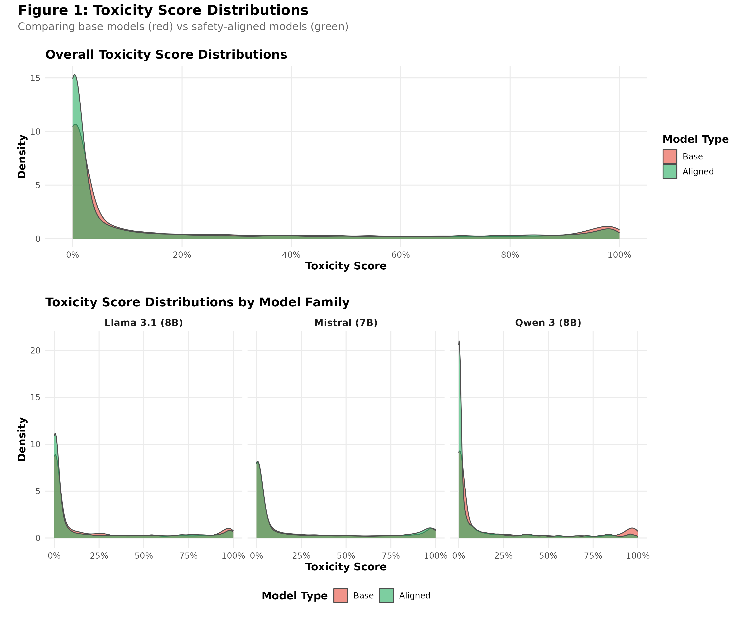
Toxicity score distributions by model type.
McNemar’s Test (Table 1): All families showed significant effects (p < 0.001). Qwen 3: ARR = 6.1% (95% CI: [5.6%, 6.5%], $χ^{2}$ = 653.59). Llama 3.1: ARR = 0.8% ($χ^{2}$ = 11.87). Mistral: ARR = -1.4% ($χ^{2}$ = 37.28)—alignment increased toxicity.
McNemar’s Test Results by Model Family
Family | b | c | Chi-sq | p-value | ARR | 95% CI
Qwen 3 (8B) | 2519 | 1002 | 653.59 | 1.04e-148 | 0.061 | [0.056, 0.065]
Llama 3.1 (8B) | 1699 | 1504 | 11.87 | 6.06e-04 | 0.008 | [0.003, 0.012]
Mistral (7B) | 1415 | 1759 | 37.28 | 1.10e-09 | -0.014 | [-0.018, -0.009]
Figure 2 shows toxicity reduction; Figure 3 shows contingency tables highlighting discordant pair asymmetry.
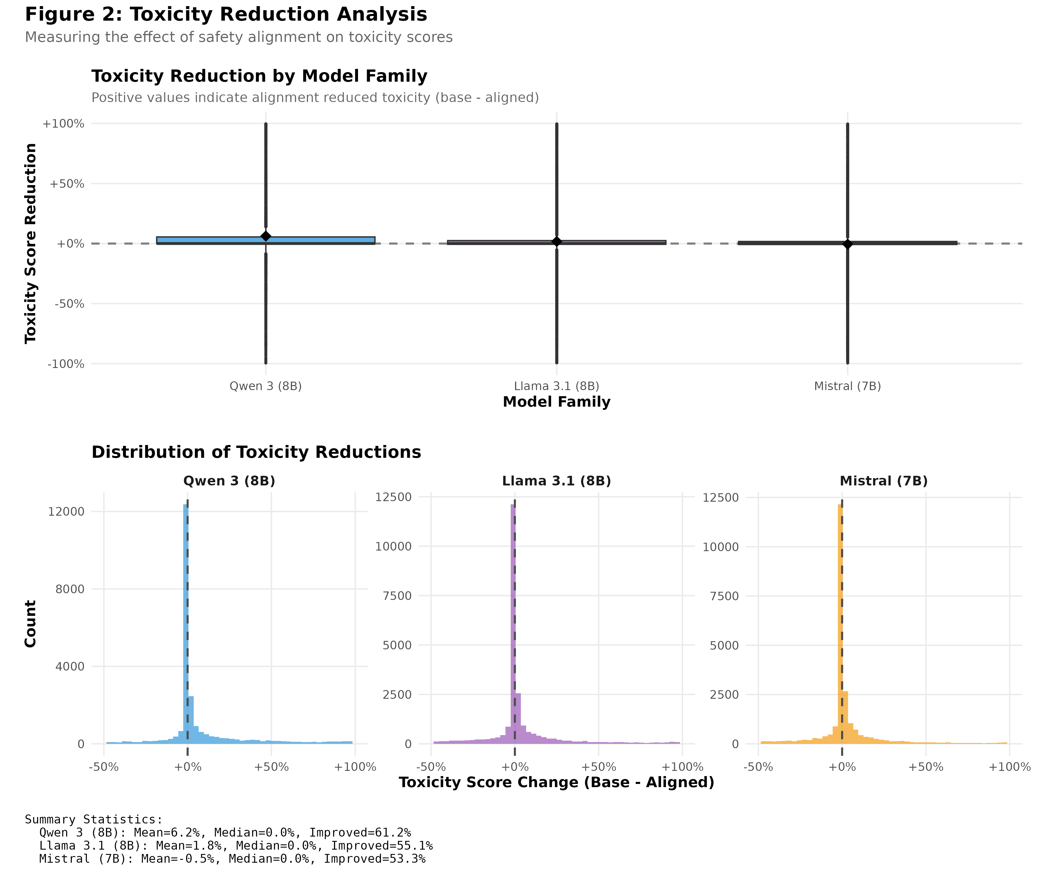
Toxicity reduction by model family.
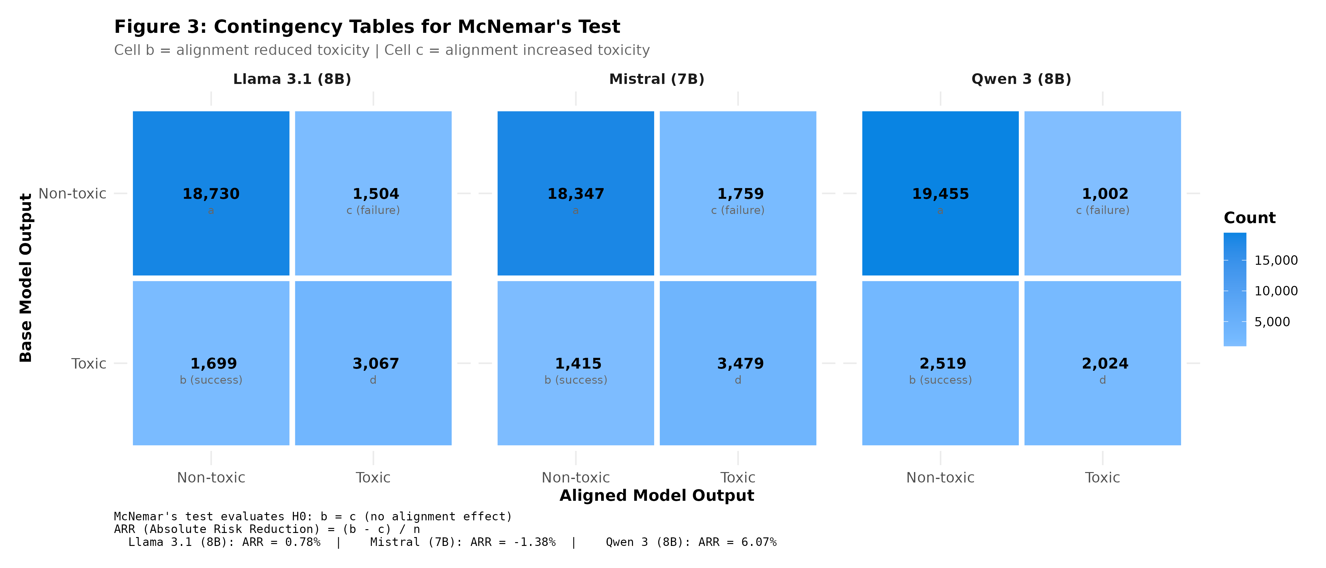
Contingency tables showing discordant pairs.
Wilcoxon Signed-Rank (Table 2): Qwen 3 (Z = 42.87, r = 0.27, medium), Llama 3.1 (Z = 16.68, r = 0.11, small), Mistral (Z = 8.80, r = 0.06). Continuous scores show Mistral reduced average toxicity, but binary analysis reveals increased threshold-crossing.
Wilcoxon Signed-Rank Test Results
Family | Z | p-value | Pseudomedian | r | % Improved
Qwen 3 (8B) | 42.87 | 0.00e+00 | 0.0068 | 0.271 | 61.2
Llama 3.1 (8B) | 16.68 | 8.72e-63 | 0.0008 | 0.106 | 55.1
Mistral (7B) | 8.80 | 6.59e-19 | 0.0003 | 0.056 | 53.3
Cochran’s Q: Significant heterogeneity ($Q$ = 442.12, $df$ = 2, $p$ = 9.9 $×$ 10$​^{−97}$). All families differ (p < 10$​^{−7}$). Success rates: Qwen 3 (55.4%), Llama 3.1 (35.6%), Mistral (28.9%).
Robustness (Figure 4): Detoxify-OpenAI agreement: r = 0.98, $κ$ > 0.93. Both scorers agree on direction for all families.
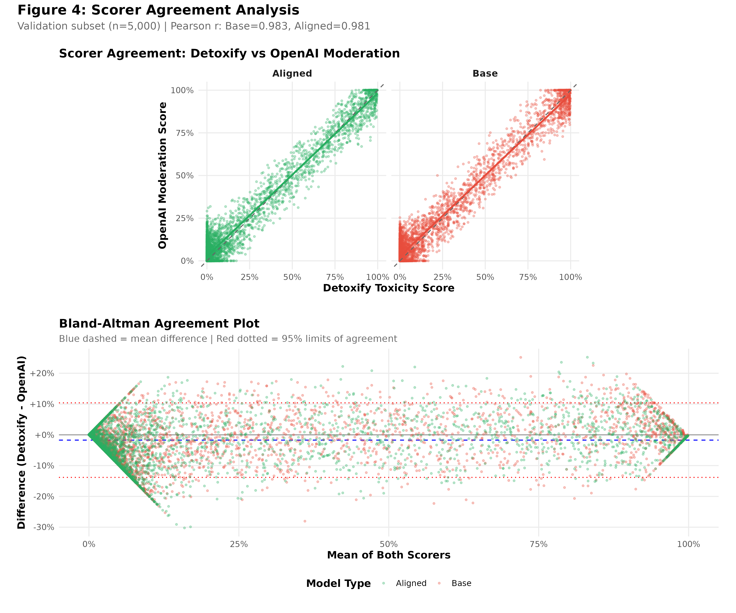
Scorer agreement between Detoxify and OpenAI Moderation.
xFakeSci (Figure 5): Exploratory linguistic pattern analysis using features from Hamed & Wu (2023).
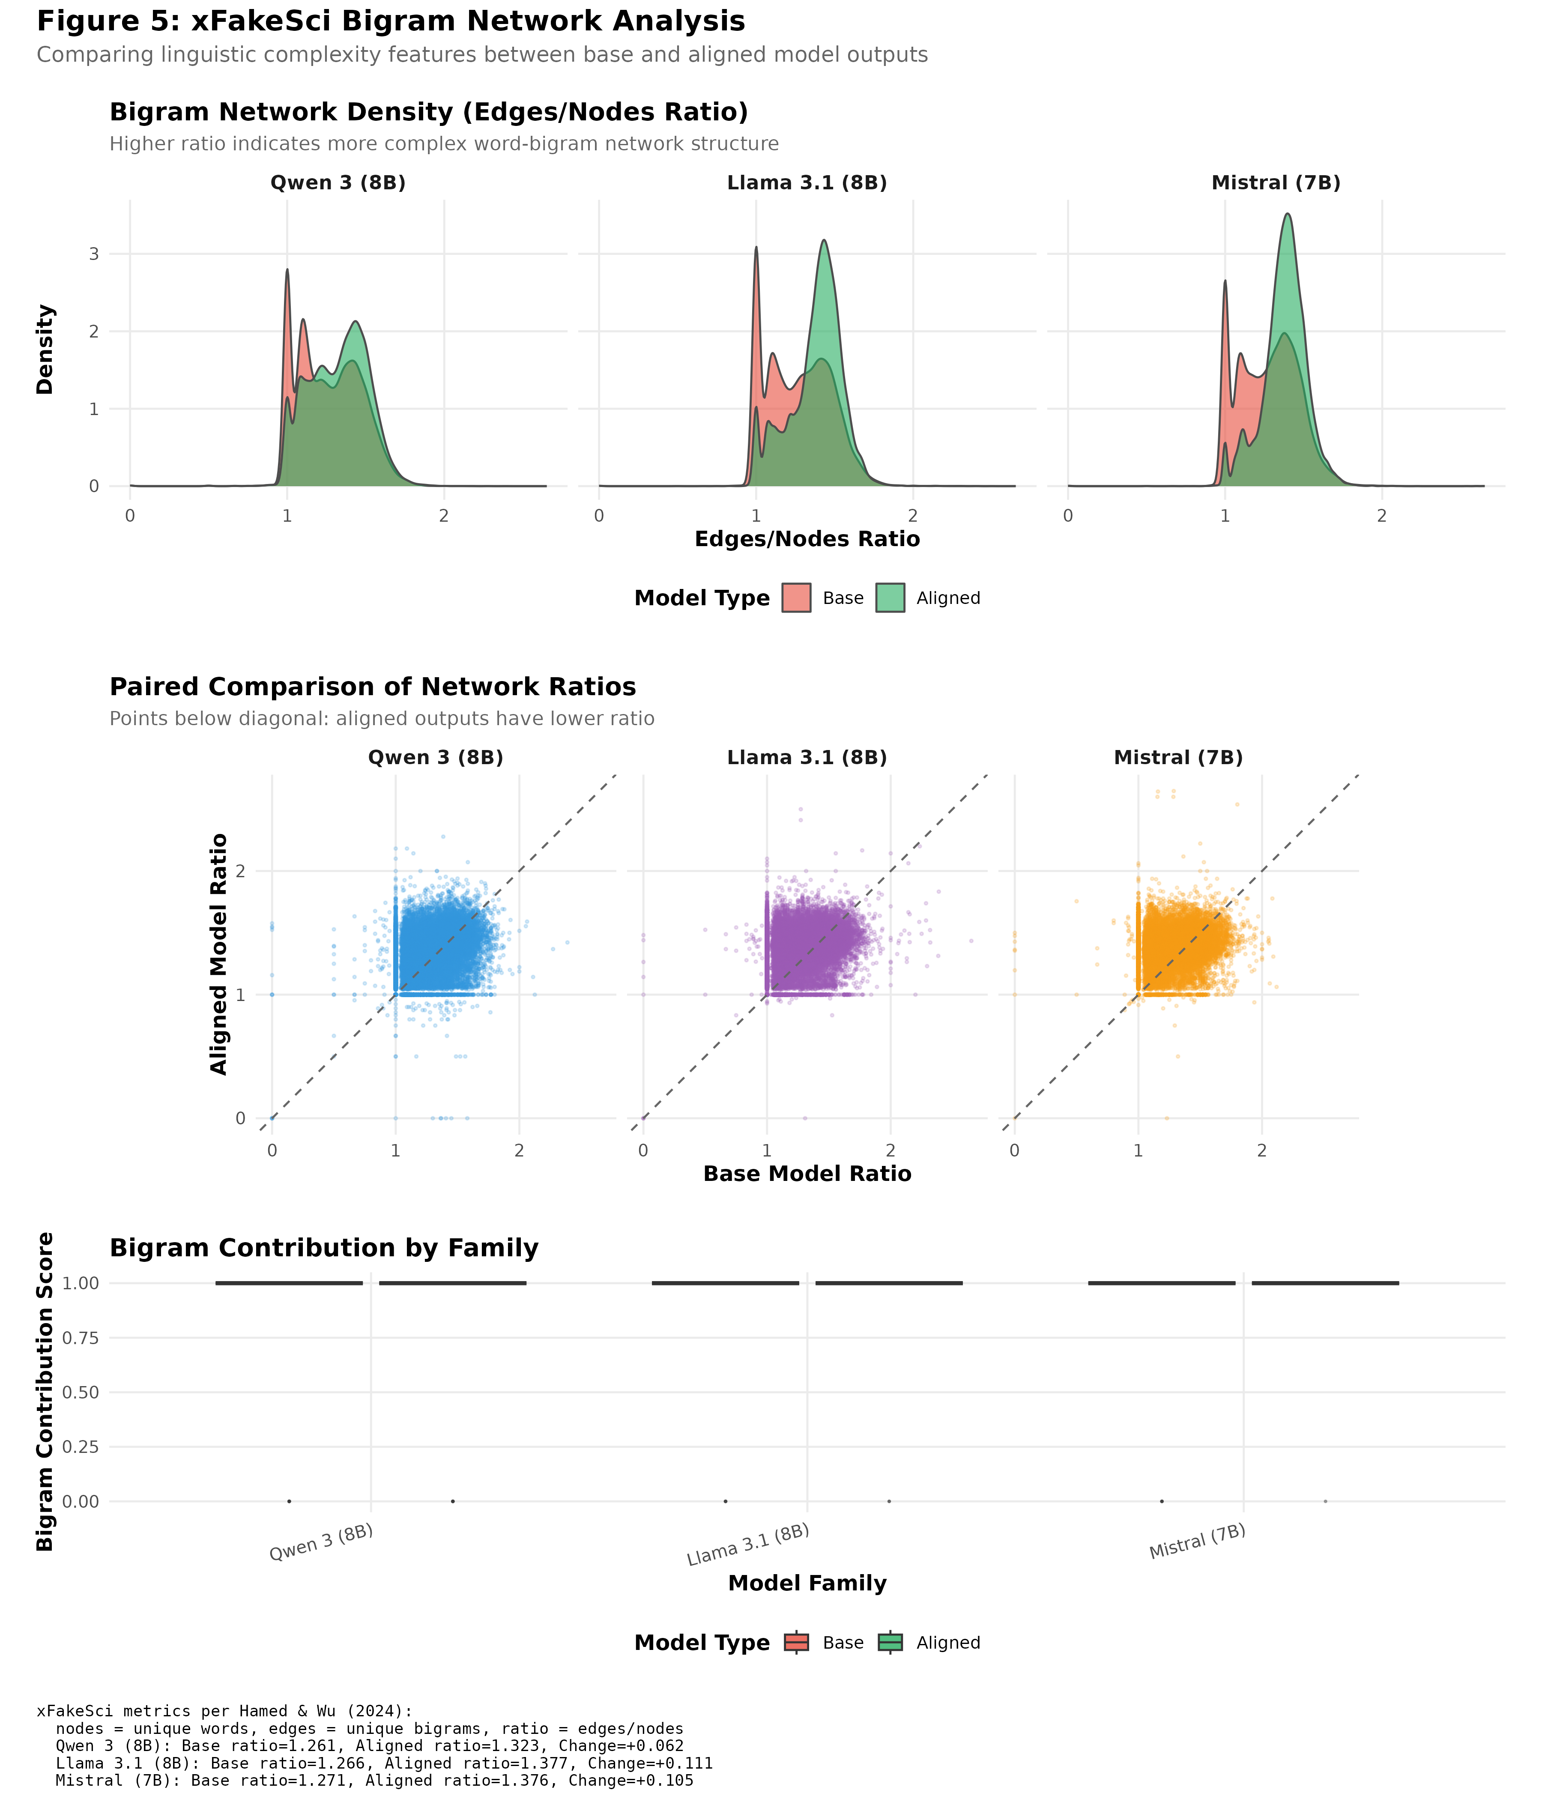
xFakeSci ratio distributions.

Discussion
Our findings challenge the assumption that alignment universally reduces toxicity. Results varied dramatically: Qwen 3 (ARR = 6.1%), Llama 3.1 (ARR = 0.8%), and surprisingly, Mistral (ARR = -1.4%, increased toxicity). The robustness analysis confirms these findings—Detoxify and OpenAI Moderation showed near-perfect agreement (r = 0.98, $κ$ > 0.93), with concordant conclusions for all families.
Limitations include reliance on automated classifiers (though validated by inter-scorer agreement), deterministic decoding (temperature = 0) which may not generalize, and the conventional 0.5 toxicity threshold. The cross-family heterogeneity ($Q$ = 442.12, p < 10$​^{−96}$) suggests alignment interacts with architecture in complex ways. The negative Mistral result is particularly concerning—some alignment procedures may inadvertently increase harmful outputs. Future work should investigate whether specific methods (RLHF, DPO, SFT) differentially affect toxicity.

References
Gehman, S., Gururangan, S., Sap, M., Choi, Y., & Smith, N. A. (2020). RealToxicityPrompts: Evaluating neural toxic degeneration in language models. Findings of EMNLP 2020.
Hamed, A. A., & Wu, X. (2023). Detection of ChatGPT fake science with the xFakeSci learning algorithm. https://arxiv.org/pdf/2308.11767
Hanu, L., & Unitary team. (2020). Detoxify. GitHub repository. https://github.com/unitaryai/detoxify
Hartvigsen, T., Gabriel, S., Palangi, H., Sap, M., Ray, D., & Kamar, E. (2022). ToxiGen: A large-scale machine-generated dataset for adversarial and implicit hate speech detection. Proceedings of ACL 2022.
Ouyang, L., Wu, J., Jiang, X., et al. (2022). Training language models to follow instructions with human feedback. Advances in Neural Information Processing Systems, 35.
Rafailov, R., Sharma, A., Mitchell, E., et al. (2023). Direct preference optimization: Your language model is secretly a reward model. Advances in Neural Information Processing Systems, 36.

